Christopher Michel, MD
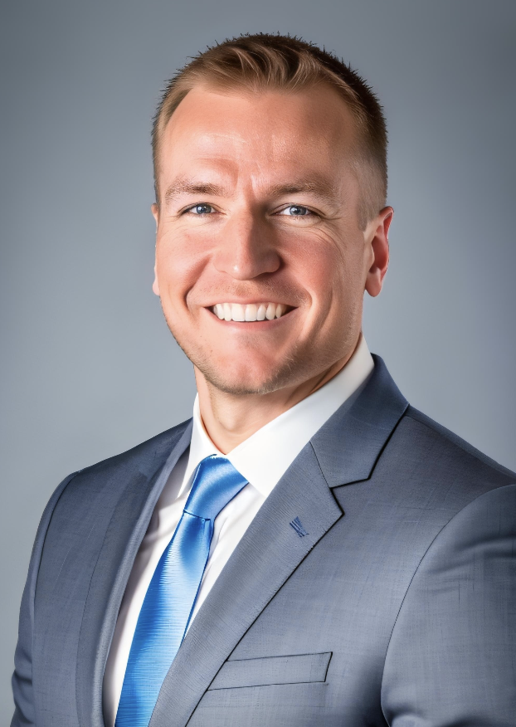
Orthopedic Spine Surgery

Experience

2025-Present Center for Advanced Orthopedics Parkway Division Hagerstown, MD
Orthopedic Spine Surgeon

Education & Training

2024-2025 William Beaumont University Hospital Royal Oak, MI
Spine Surgery Fellowship

2019-2024 Rutgers RWJ Barnabas Health Monmouth Medical Center Long Branch, NJ
Orthopedic Surgery Residency

2015–2019 Temple University Lewis Katz School of Medicine Philadelphia, PA
Doctor of Medicine (M.D.)

2010-2014 Temple University Honors College Philadelphia, PA
B.A. Biological Sciences, Magna Cum Laude

Honors & Awards

2024 Cervical Spine Research Society 2024 Hands-on Techniques Course Resident Scholarship
2023 Cervical Spine Research Society 2023 Annual Meeting Resident Scholarship
2021 F&J Orthopedics Award: 2021 Ellen Cosgrove Research Competition
Has COVID-19 Influenced Future Post-Operative Protocols for Patients Undergoing a Primary Total Joint Arthroplasty? A Retrospective Review
2020 Best Overall Paper: 2020 Ellen Cosgrove Research Competition
Variability in Resident Perception of the Cost of Radiology Studies
2018 Alpha Omega Alpha Medical Honor Society, Temple University School of Medicine
2015 Althea J. Carnell Scholarship, Temple University School of Medicine
2014 Magna Cum Laude, Temple University
2014 Temple University Academic Merit Scholarship
2013 Phi Beta Kappa
2010-2014 Dean’s List, Temple University

MEMBERSHIPS AND HONORARY/PROFESSIONAL SOCIETIES

2023 Cervical Spine Research Society, Member
2022 North American Spine Society, Member
2019 New Jersey Orthopedic Society, Member
2019 Eastern Orthopedic Society, Member
2019 American Academy of Orthopedic Surgeons, member

COURSES

2024 Lumbar Spine Research Society Hands-on Techniques Course Indianapolis, IN
2024 Cervical Spine Research Society Hands-on Techniques Course Indianapolis, IN
2024 Stryker Pre-Fellows Spine Summit Chicago, IL
2023 Globus Current Trends and Surgical Solutions for Senior Residents Philadelphia, PA
2022 Synthes Trauma for Senior Residents Course Denver, CO
2021 Synthes Advanced Intramedullary Nailing Course Phoenix, AZ
LANGUAGES

English, native/functionally native, Spanish, conversational

HOBBIES & INTERESTS

Fishing, surfing, Philadelphia sports

Publications

Chan P, Michel C, Colon A, Clune J, Shah A. The Treatment of Complex Extremity Wounds Using External Tissue Expansion: A Case Series. Journal of Plastic and Reconstructive Surgery. 2022 December.

- Michel C, Dijanic C, Sudah S, Kerrigan D, Cohen J. Effect of Psychiatric Comorbidities on Perioperative Outcomes Following Anterior Cervical Discectomy and Fusion. North American Spine Society Journal. 2022 September.

- Smith T, Sudah S, Manzi J, Michel C, Kerrigan D, Dijanic C, Constantinescu D, Menendez M, Plyler R. The Relative Citation Ratio: Evaluating a New Measure of Scientific Influence Among Academic Sports Medicine Surgeons. Orthopedic Journal of Sports Medicine. 2022 August.

- Imam N, Sudah S, Manzi J, Michel C, Pizzo D, Menendez M, Nicholson A. Pediatric Shoulder Arthroscopy is Effective and Most Commonly Indicated for Instability, Obstetric Brachial Plexus Palsy, and Partial Rotator Cuff Tears. Arthroscopy, Sports Medicine, and Rehabilitation. 2022 July.

- Dijanic C, Sudah S, Michel C, Smith T, Patankar A, Manzi J, Faccone R, Kerrigan D, Menendez M, Cohen J. Evaluation of the National Institutes of Health-Supported Relative Citation Ratio among American Orthopedic Spine Surgery Faculty: A New Bibliometric Measure of Scientific Influence. North American Spine Society Journal. 2022 June.

- Michel C, Dijanic C, Abdelmalek G, Sudah S, Kerrigan D, Gorgy G, Yalamanchili P. Readability Assessment of Patient Educational Materials for Pediatric Spinal Deformity from Top Academic Orthopedic Institutions. Spine Deformity. 2022 June.

- Michel C, Dijanic C, Abdelmalek G, Sudah S, Kerrigan D, Yalamanchili P. Readability Assessment of Patient Educational Materials for Pediatric Spinal Conditions from Top Academic Orthopedic Institutions. Journal of Children’s Orthopedics. 2022 June

- Sudah S, Michel C, Faccone R, Kirchner G, Kim R, Menendez M, Gabisan G. Ankle Arthroscopy Procedural Volume is Low Among Graduating Orthopedic Surgery Residents. Arthroscopy, Sports Medicine, and Rehabilitation. 2022 June.

- Sudah S, Michel C, Nasra M, Faccone R, Constantinescu D, Menendez M, Plyler R. Hip Arthroscopy Procedural Volume is Low Among Graduating Orthopedic Surgery Residents. Arthroscopy, Sports Medicine, and Rehabilitation. 2022 May. PMID: 35747642

- Chan P, Michel C, Colon A, Clune J, Shah A. The Treatment of Complex Extremity Wounds Using External Tissue Expansion: A Case Series. Journal of Plastic and Reconstructive Surgery. 2022 May

- McNamara J, Henderson M, Sudah S, Faccone R, Michel C, Dijanic C, Menendez M, Ruskin J. Evaluation of the Relative Citation Ratio Among Academic Orthopedic Hand Surgeons: A Novel Measure of Research Impact. Cureus. 2022 May. PMID: 35774708

- Sudah S, Faccone R, Michel C, Dijanic C, Kerrigan D, Menendez M, Namdari S, Nicholson A. The Number of Shoulder and Elbow Questions on the Orthopedic In-Training Examination is Increasing with Greater Emphasis on Critical Thinking over Recall. Journal of Shoulder and Elbow Surgery: Reviews, Reports & Techniques. 2022 April.

- Michel C, Dijanic C, Abdelmalek G, Sudah S, Kerrigan D, Yalamanchili P. Upper Cervical Spine Instability Systematic Review: A Bibliometric Analysis of the 100 Most Influential Publications. Journal of Spine Surgery. 2022 April. PMID: 35875624

- Michel C, Abdelmalek G, Sudah S, Kerrigan D, Dijanic C, Ali S. Septic Tenosynovitis and Rupture of the Tibialis Anterior Tendon: A Case Report and Review of the Literature. Foot & Ankle Surgery: Techniques, Reports & Cases. 2022 March.

- Michel C, Dijanic C, Sudah S, Kerrigan D, Cohen J. Has Public Interest in Elective Spine Surgery Returned to Pre-COVID 19 Levels? A Google Trends Analysis. Cureus. 2022 March. PMID: 35392447

- Sudah S, Michel C, Menendez M, Plyler R. Wide Variability of Shoulder and Elbow Case Volume in Orthopedic Surgery Residency. Journal of Shoulder and Elbow Surgery. 2022 February. PMID: 34358667

- Sudah S, Constantinescu D, Nasra M, Michel C, Dijanic C, Kerrigan D, Plyler R. Wide Variability of Pediatric Knee Arthroscopy Case Volume in Orthopedic Surgery Residency. Arthroscopy, Sports Medicine and Rehabilitation. 2021 September. PMID: 34977632

- Nasra M, Michel C, Sudah S, Dijanic C, Torpey B. Anterior Hip Dislocation After Hip Arthroscopy Complicated by Iliopsoas Bursitis. Cureus. 2021 August. PMID: 34522522

- Nasra M, Dijanic C, Sudah S, Michel C, Cohen J. Simultaneous Bilateral Patellar Tendon Rupture in a Patient With Osteogenesis Imperfecta. Cureus. 2021 June. PMID: 34258126

- Sudah S, Nasra M, Michel C, Dijanic C, Kerrigan D, Curatolo E. Patella Sleeve Fracture with Medial Patellofemoral Ligament Tear and Lateral Femoral Condyle Fracture in an Adolescent: A Case Report. JBJS Case Connect. 2021 October. PMID: 34669654

- Michel C, Dijanic C, Woernle M, Fernicola J, Grossman J. Carpal Tunnel Syndrome Secondary to Fibrolipomatous Hamartoma of the Median Nerve. Cureus. 2021 June. PMID: 34239795

- Sudah S, Michel C, Dijanic C, Kerrigan D, Gesell M. Bullous Pemphigoid After Total Knee Arthroplasty. Arthroplasty Today. 2021 April. PMID: 34041328

- Mukherjee S, Zhou G, Michel C, Voelz V. Insights into Peptoid Helix Folding Cooperativity from an Improved Backbone Potential. Journal of Physical Chemistry. 2015. PMID: 26584227

Book Chapters

- Michel C, Collins C. Pediatric Neuromuscular Disorders. Pediatric Clinics of North America. 2020 February. PMID: 31779836
- Michel C, Park D. Revision Surgery: Biportal Endoscopic Discectomy. Essentials of Endoscopic Spine Surgery. 2025 May.
- Michel C, Kroenung P, Cox Z, Park D. Endoscopic Transforaminal Lumbar Interbody Fusion.

Podium Presentations

- Lipphardt, M, Zakko P, Michel C, Park D. Perception of Ergonomics and Related Physical Symptoms Among Spine Surgeons: A Survey-Based Study. Lumbar Spine Research Society Annual Meeting. 2025 May. Chicago, IL.

- Sudah S, Michel C, Faccone R, Kirchner G, Kim R, Menendez M, Gabisan G. Ankle Arthroscopy Procedural Volume is Low Among Graduating Orthopedic Surgery Residents. Eastern Orthopedic Association 2022 Annual Meeting. 2022 October. Naples, FL.

- Michel C, Dijanic C, Sudah S, Kerrigan D, Cohen J. Effect of Psychiatric Comorbidities on Perioperative Outcomes Following Anterior Cervical Discectomy and Fusion. New Jersey Orthopedic Society 2022 Annual Meeting. 2022 May. New Brunswick, NJ.

- Kerrigan D, Michel C, Sudah S, Dijanic C. Dislocation after Reverse Total Shoulder Arthroplasty. New Jersey Orthopedic Society 2022 Annual Meeting. 2022 May. New Brunswick, NJ.

- Sudah S, Michel C, Menendez M, Plyler R. Wide Variability in Shoulder and Elbow Case Volume in Orthopedic Surgery Residency. Orthopedic Summit 2021. Las Vegas, NV.

- Michel C, Chan P, Rossi K, Clune J, Shah A. The Benefits of External Tissue Expansion in Complex Extremity Reconstruction: A Case Series. Plastic Surgery: The Meeting 2021. Atlanta, GA.

- Gorgy G, Dijanic C, Michel C, Sudah S, Kerrigan D, Cohen J. Epidemiology, Incidence, and Survival of Ependymoma of the Spinal Cord: A study of the SEER Database. Eastern Orthopedic Association Meeting 2021. Nashville, TN.

- Michel C, Nasra M, Sudah S, Dijanic C, Kerrigan D, Grossman J, Torpey B. Anterior Hip Dislocation Following Arthroscopy. New Jersey Orthopedic Society 2021 Annual Meeting. 2021 May. New Brunswick, NJ.

Poster Presentations

- Michel C, Dijanic C, Abdelmalek G, Sudah S, Kerrigan D, Yalamanchili P. Readability Assessment of Patient Educational Materials for Pediatric Spinal Conditions from Top Academic Orthopedic Institutions. Eastern Orthopedic Association 2022 Annual Meeting. 2022 October. Naples, FL.

- Michel C, Dijanic C, Sudah S, Kerrigan D, Cohen J. Effect of Psychiatric Comorbidities on Perioperative Outcomes Following Anterior Cervical Discectomy and Fusion. North American Spine Society 2022 Annual Meeting. 2022 October. Chicago, IL.

- Michel C, Abdelmalek G, Sudah S, Garber H, Kerrigan D, Dijanic C, Ali S. Septic Tenosynovitis and Rupture of the Tibialis Anterior Tendon: A Case Report and Review of the Literature. American Orthopedic Foot and Ankle Society 2022 Annual Meeting. 2022 October. Quebec City, Canada.

- Sudah S, Michel C, Faccone R, Garber H, Kirchner G, Kim R, Menendez M, Gabisan G. Ankle Arthroscopy Procedural Volume is Low Among Graduating Orthopedic Surgery Residents. American Orthopedic Foot and Ankle Society 2022 Annual Meeting. 2022 October. Quebec City, Canada.

- Mcnamara J, Henderson M, Sudah S, Faccone R, Michel C, Dijanic C, Menendez M, Ruskin J. Evaluation of the Relative Citation Ratio Among Academic Orthopedic Hand Surgeons: A Novel Measure of Research Impact. American Society for Surgery of the Hand 2022 Annual Meeting. 2022 September. Boston, MA.

- Patankar A, Sudah S, Michel C, Constantinescu D, Menendez M, Ruskin J, Shah A. Low Rates of Reporting and Analysis by Race and Ethnicity in Randomized Control Trials Published within the Journal of Hand Surgery. American Society for Surgery of the Hand 2022 Annual Meeting. 2022 September. Boston, MA.

- Michel C, Chan P, Rossi K, Clune J, Shah A. The Benefits of External Tissue Expansion in Complex Extremity Reconstruction: A Case Series. Northeastern Society of Plastic Surgeons 2021 Annual Meeting. 2021 September. Philadelphia, PA.

- Gorgy G, Dijanic C, Michel C, Sudah S, Kerrigan D, Cohen J. Epidemiology, Incidence, and Survival of Ependymoma of the Spinal Cord: A study of the SEER Database. Orthopedics Today 2021. 2021 September. Wailea, HI.

- Gorgy G, Dolitsky B, Dijanic C, Michel C, Cohen J. Nephrotoxic Effects of Vancomycin Powder in Spine Surgery Patients. Orthopedics Today 2021. 2021 September. Wailea, HI.

- Dijanic C, Michel C, Grossman J, Dolitsky R, Gesell M. Clinical Efficacy of Tourniquet Use During a Primary Total Knee Arthroplasty: A Retrospective Review. American Academy of Orthopedic Surgeons 2021 Annual Meeting. 2021 August. San Diego, CA.

- Sindhu S, Wojda T, Ceesay N, Michel C, Smith J, Decker E. Acute Bronchitis: Prescription Patterns of Healthcare Providers in an Outpatient Clinic. 2018 Annual St. Luke’s University Health Network Research Day. 2018 May. Bethlehem, PA.

- Michel C, Voelz V. Can Current Force Field Models Accurately Simulate Peptoids? Temple University Undergraduate Research Symposium. 2012 August. Philadelphia, PA.

- Michel C, Voelz V. Can Current Force Field Models Accurately Simulate Peptoids? American Chemical Society National Meeting. 2012 August. Philadelphia, PA.

